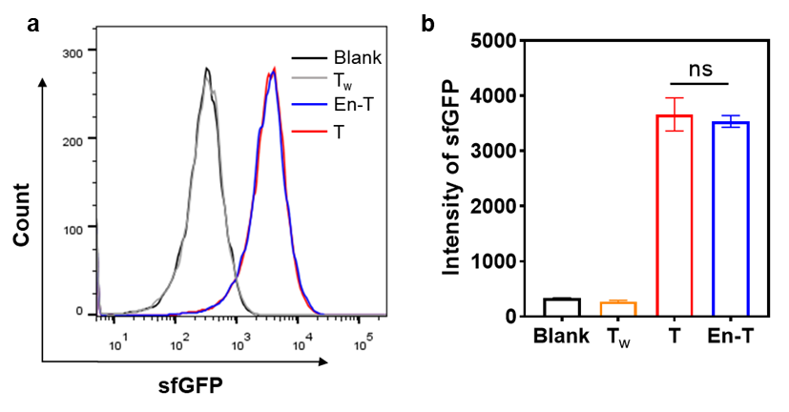
Supplementary Fig. 1. Assessment of toehold-switch activation by conventional and spacer-containing triggers. (a) Representative flow cytometry histograms of sfGFP fluorescence in E. coli cells expressing the toehold switch in the presence of a non‑targeting control trigger (Tw), a conventional trigger (T), or an engineered trigger containing a spacer (En‑T). (b) Quantitative comparison of mean sfGFP fluorescence intensity across the different trigger groups, measured by flow cytometry. ns, not significant. Data are presented as mean ± SEM (n = 3 per group). ns, not significant.

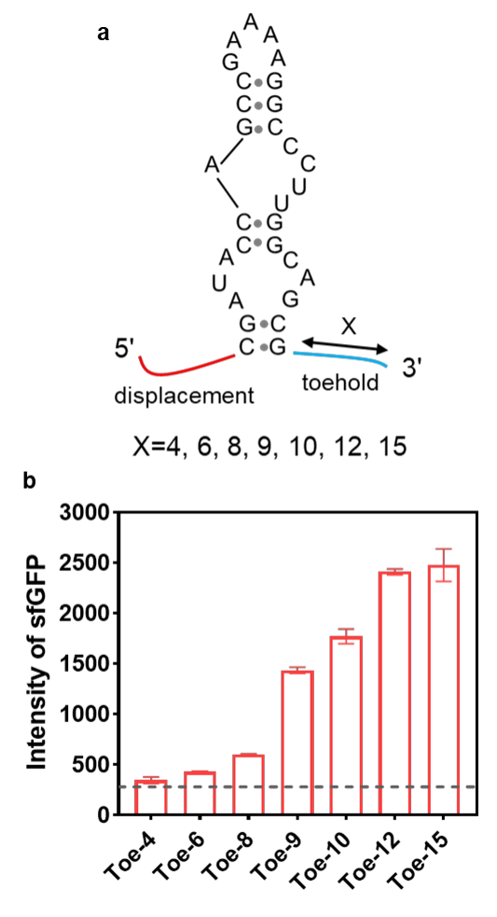
Supplementary Fig. 2. Optimization of toehold length in engineered trigger RNAs for toehold-switch activation. (a) Schematic of toehold length variants tested in the engineered trigger RNA (En‑T). (b) Quantitative analysis of toehold-switch activation by En‑T constructs with different toehold lengths (4, 6, 8, 9, 10, 12, and 15 nt). Switch activity is reported as mean sfGFP fluorescence intensity measured by flow cytometry. The gray dotted line indicates background fluorescence from a non‑activating control. Data are presented as mean ± SEM (n = 3 per group).

a
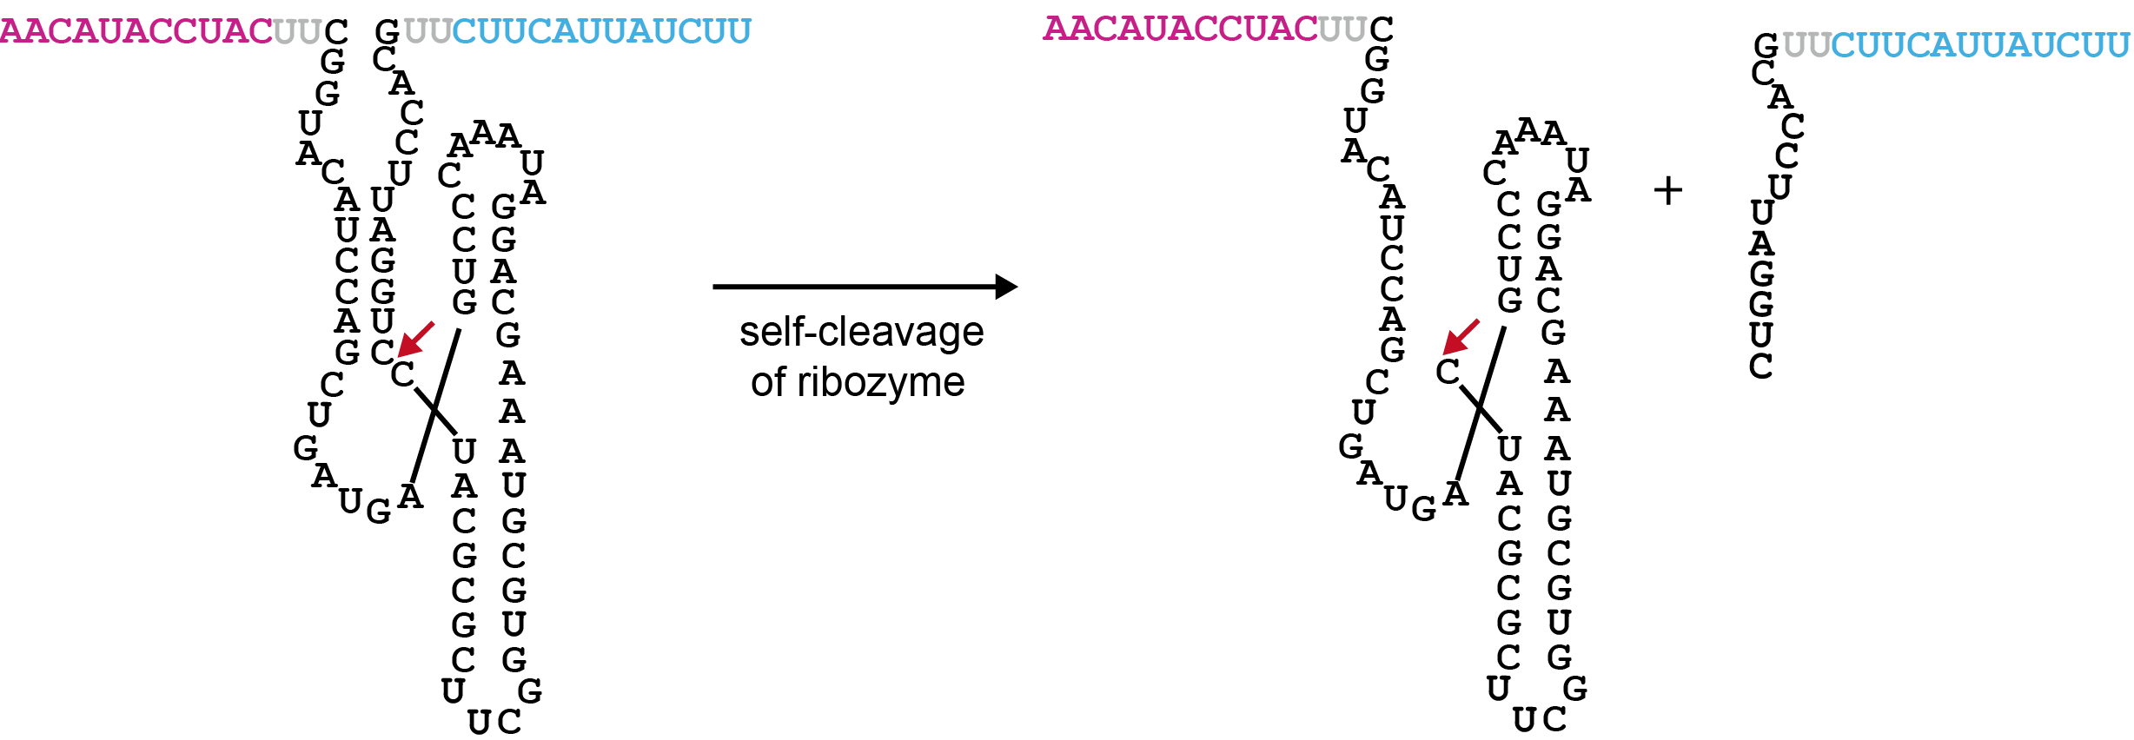
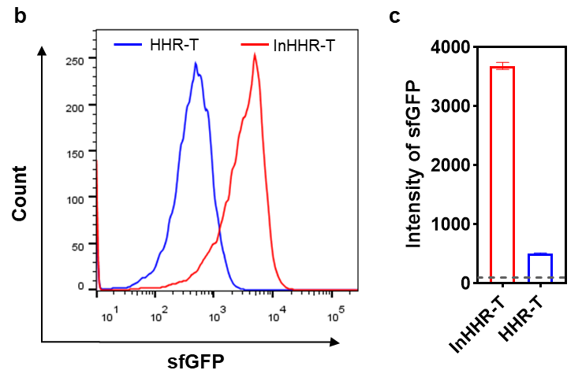
Supplementary Fig. 3. Functional analysis of a ribozyme‑embedded trigger RNA (HHR‑T) on toehold‑switch regulation. (a) Schematic of the HHR‑T construct, in which a hammerhead ribozyme (HHR) is inserted between the toehold and displacement domains. The self‑cleavage activity of HHR is expected to disrupt trigger integrity. (b) Representative flow cytometry profiles of sfGFP fluorescence in E. coli cells expressing the toehold switch together with either HHR‑T or a control trigger containing an inactive HHR variant (InHHR‑T). (c) Quantitative comparison of mean sfGFP fluorescence intensity between the HHR‑T and InHHR‑T groups. The gray dotted line indicates background fluorescence from a non‑activating control. Data are presented as mean ± SEM (n = 3 per group).

a
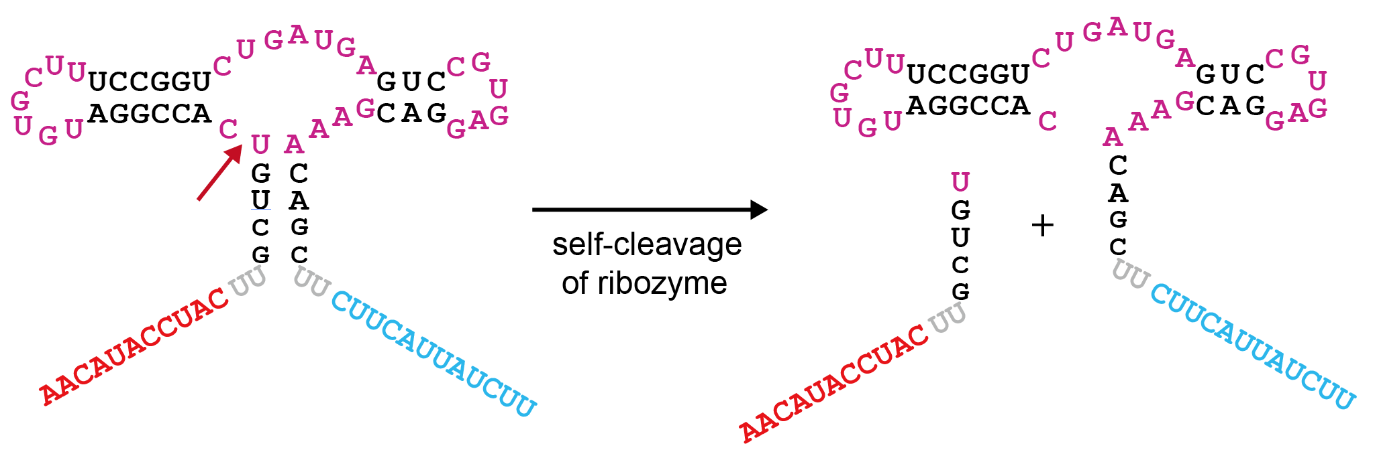
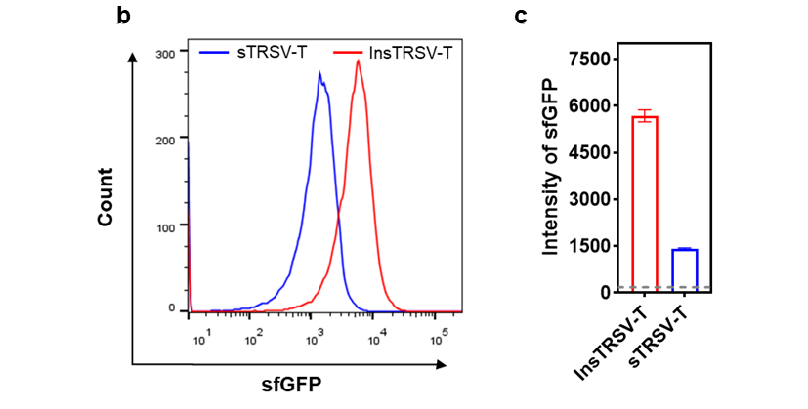
Supplementary Fig. 4. Functional validation of a satellite RNA of tobacco ringspot virus (sTRSV) ribozyme‑embedded trigger RNA (sTRSV‑T) on toehold‑switch regulation. (a) Schematic of the sTRSV‑T construct, in which the sTRSV self‑cleaving ribozyme is inserted between the toehold and displacement domains. The constitutive self‑cleavage activity of sTRSV is designed to disrupt the trigger and prevent switch activation. (b) Representative flow cytometry profiles of sfGFP fluorescence in E. coli cells expressing the toehold switch along with sTRSV‑T or a control trigger containing an inactive sTRSV variant (InsTRSV‑T). (c) Quantitative comparison of mean sfGFP fluorescence intensity between the sTRSV‑T and InsTRSV‑T groups. The gray dotted line indicates background fluorescence from a non‑activating control. Data are presented as mean ± SEM (n = 3 per group).

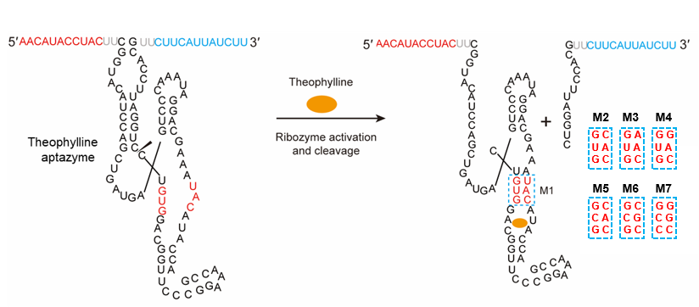
Supplementary Fig. 5. Ligand-dependent regulation of toehold switch activity using aptazyme-engineered trigger RNAs with different communication modules. Schematic of the theophylline-responsive aptazyme trigger RNA (Theo-HHR-T). The aptazyme consists of a theophylline aptamer domain (blue) fused to a hammerhead ribozyme (HHR) domain via a communication module (CM, red). M1–M7 denote seven distinct CM sequences tested.

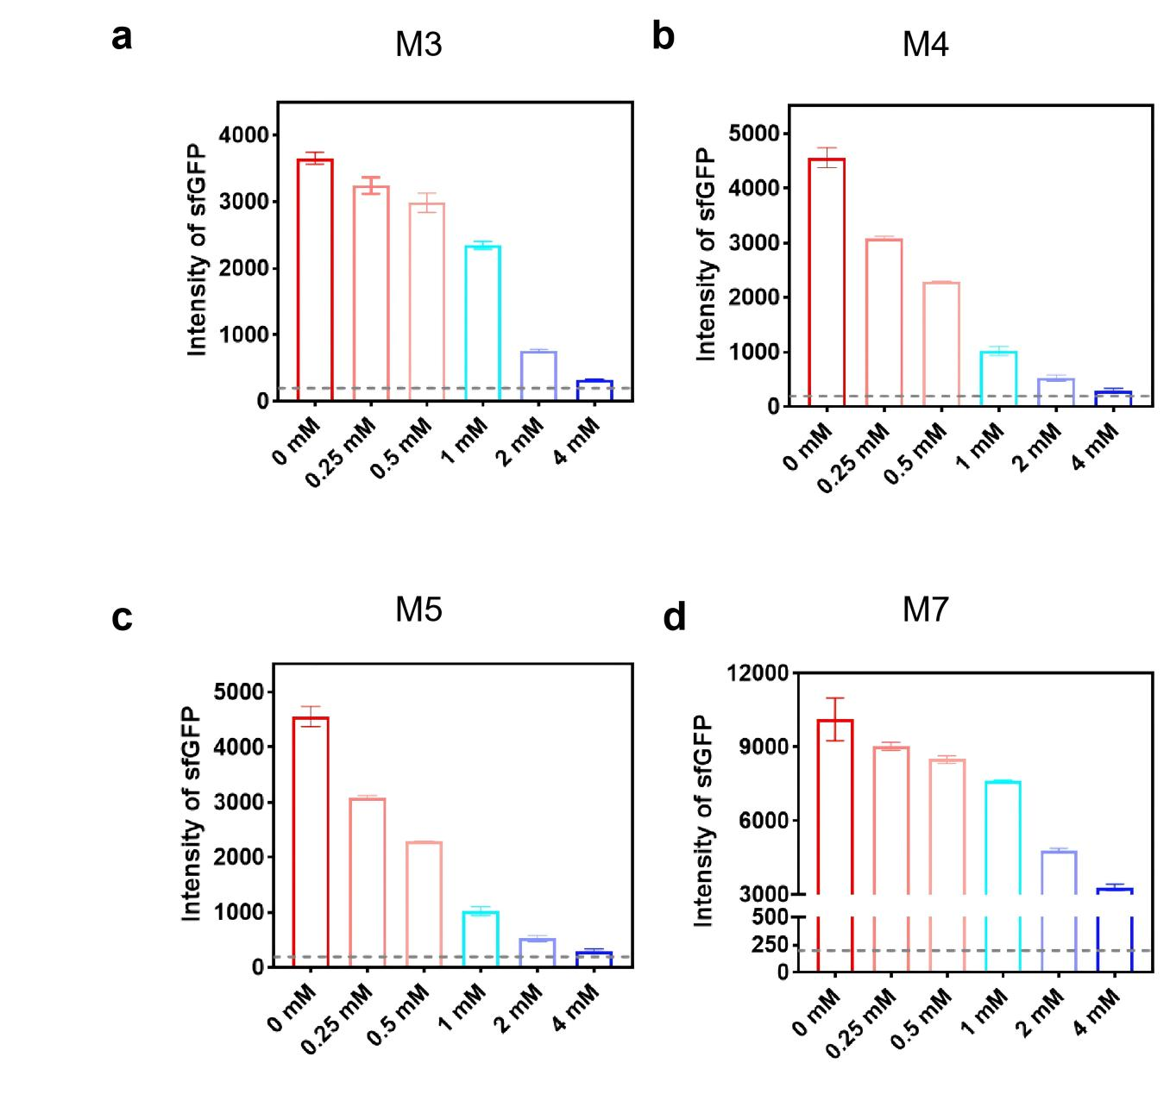
Supplementary Fig. 6. Dose‑dependent regulation of toehold‑switch activity by theophylline‑aptazyme trigger RNAs containing different communication modules. (a‑d) For each indicated communication module (M3, M4, M5, M7), each panel shows representative quantitative analysis of mean sfGFP fluorescence intensity in E. coli cells treated with increasing theophylline concentrations (0, 0.25, 0.5, 1, 2, 4 mM). The gray dotted line indicates background fluorescence from a non‑activating control. Data are presented as mean ± SEM (n = 3 per group).
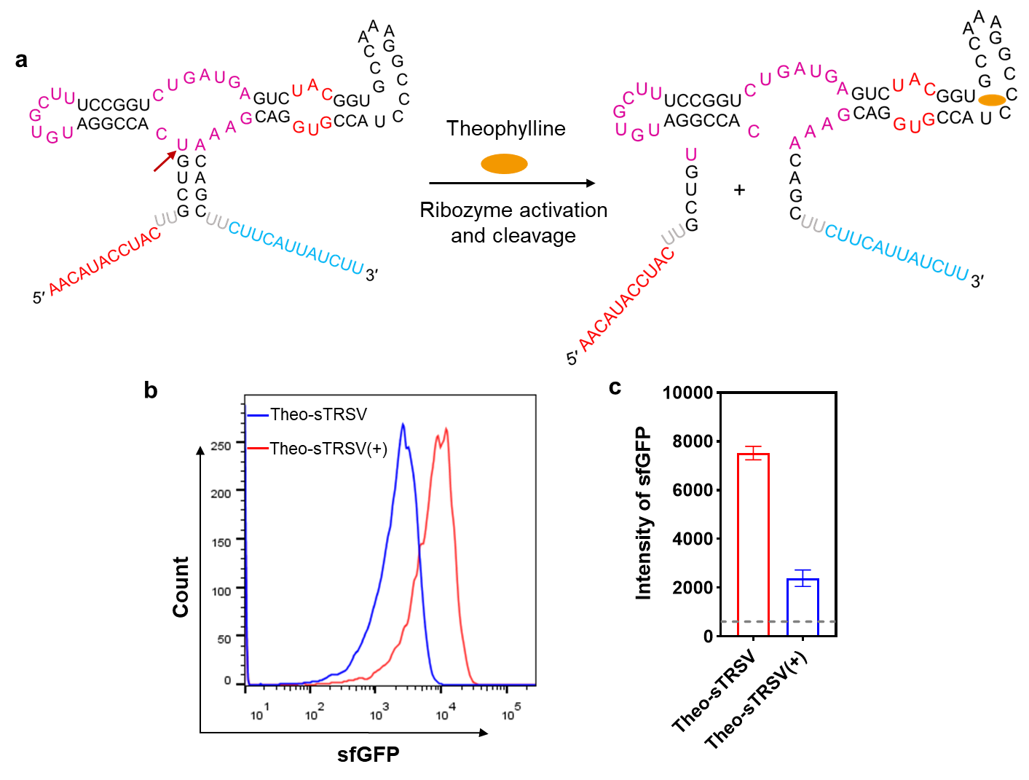
Supplementary Fig. 7. Validation of a theophylline-responsive aptazyme trigger based on the sTRSV ribozyme scaffold. (a) Schematic of the Theo‑sTRSV‑T trigger RNA, in which a theophylline‑dependent aptazyme (theophylline aptamer fused to sTRSV ribozyme) is embedded between the toehold and displacement domains. (b) Representative flow cytometry profiles of sfGFP fluorescence in E. coli cells expressing the toehold switch together with Theo‑sTRSV‑T, either untreated or treated with theophylline. (c) Quantitative analysis of mean sfGFP fluorescence intensity showing significant reduction upon theophylline addition, confirming ligand‑dependent inactivation of the trigger. The gray dotted line indicates background fluorescence from a non‑activating control. Data are presented as mean ± SEM (n = 3 per group).

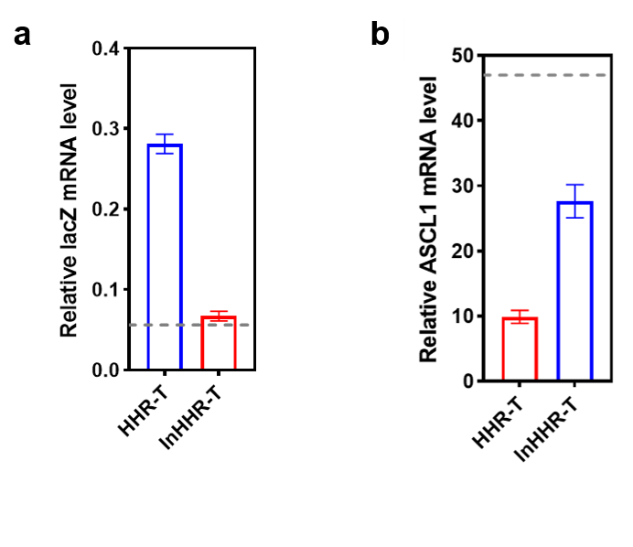
Supplementary Fig. 8. Regulation of CRISPR‑Cas9 function using ribozyme‑embedded trigger RNAs. (a) In E. coli, a hammerhead ribozyme‑containing trigger (HHR‑T) was used to control CRISPRi‑mediated repression of the lacZ gene via a toehold‑activated gRNA‑switch. Data show relative lacZ expression in cells expressing HHR‑T compared to an inactive‑ribozyme control (InHHR‑T). The gray dotted line indicates repression achieved by a constitutively active gRNA. (b) In HEK‑293T cells, the same ribozyme trigger (HHR‑T) was employed to regulate CRISPRa‑driven upregulation of the endogenous ASCL1 gene. Results are presented as fold activation relative to a non‑targeting control. The gray dotted line represents activation by a constitutively active gRNA. Data are presented as mean ± SEM (n = 3 per group).

